Belt Drive USB/Bluetooth Turntable

33 1/3 and 45 rpm with Auto-Stop
Aluminium tone arm & platter
Real Wood Veneer
Mitchell Acoustics high-end moving magnet cartridge

USB recording & built-in PHONO pre-amp
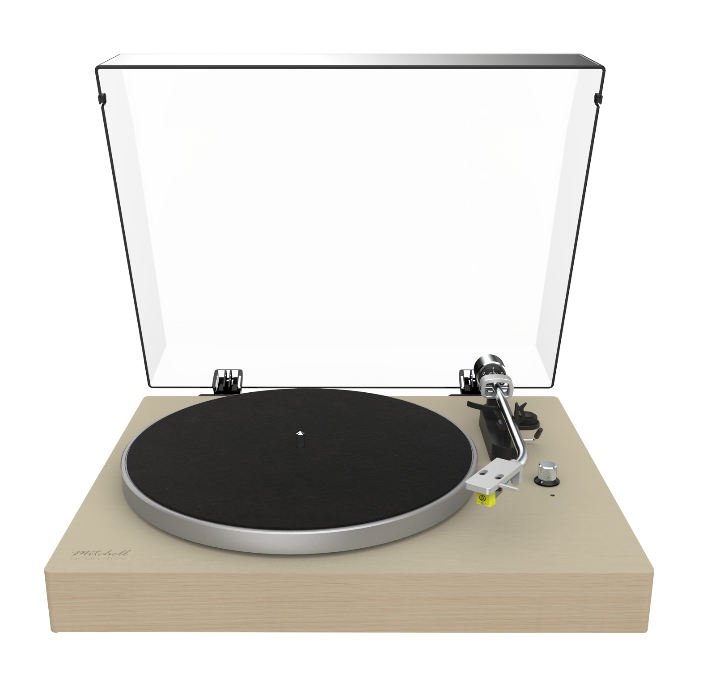
Anti-interference coupling circuit

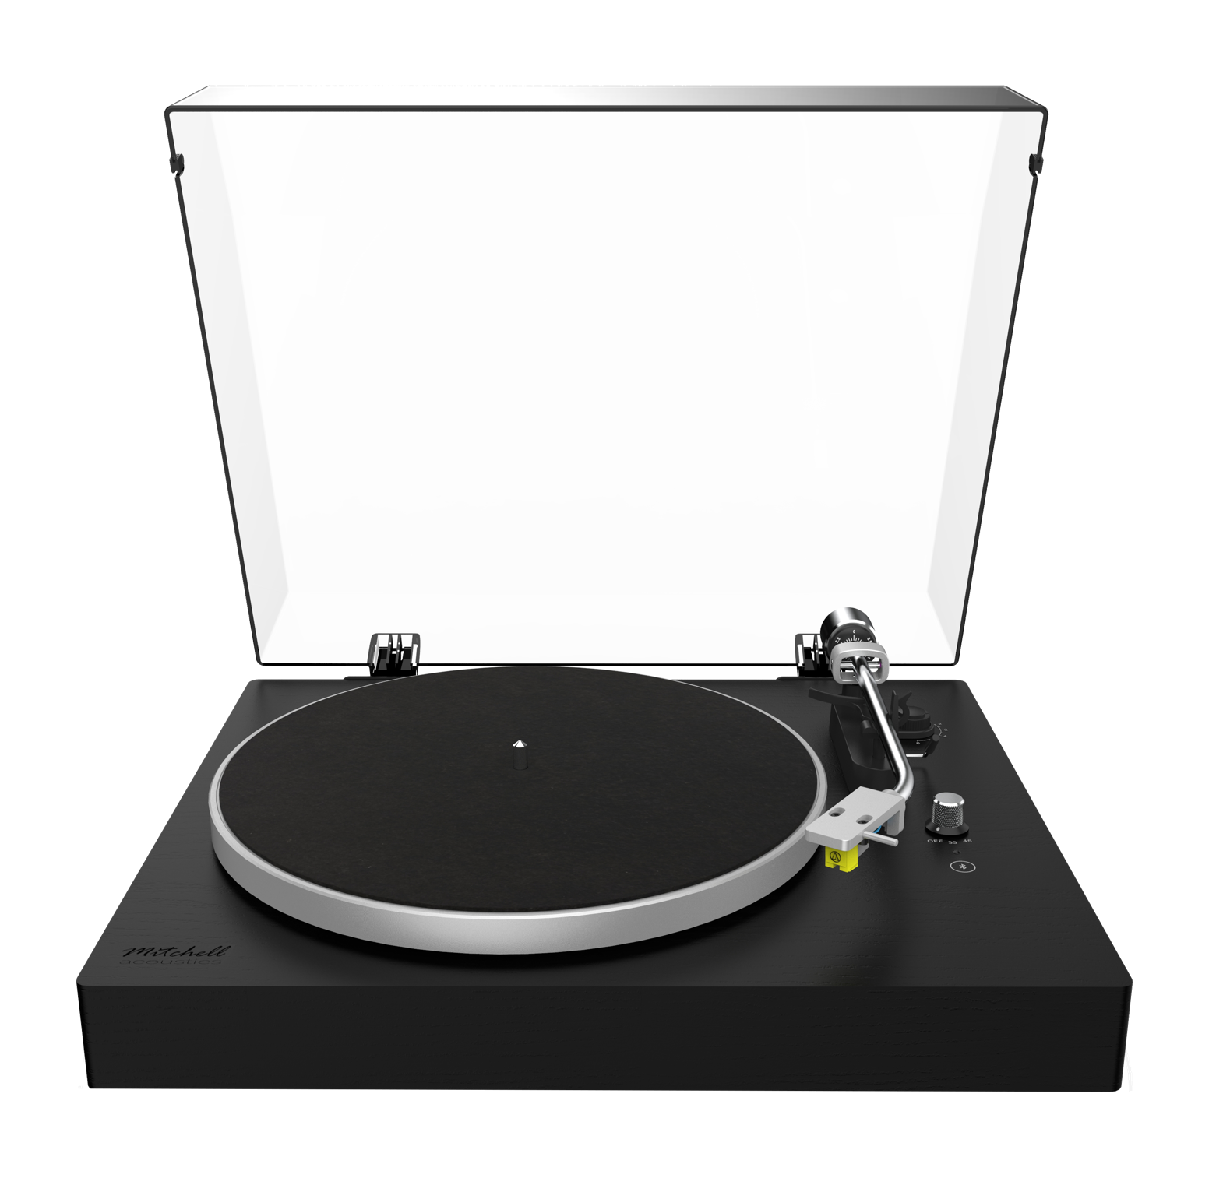

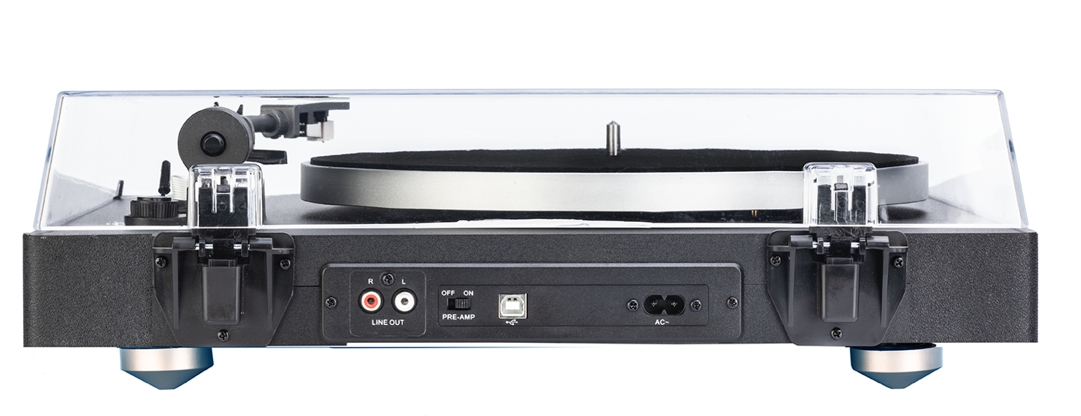

SPECIFICATION

Top Panel Controls | Speed Rotary Selector (33^{1/3} rpm – 45 rpm)  Bluetooth Pairing Touch Control
Rear Panel Controls | Slide Switch for Pre-amplifier On/OFF selection for RCA jack output
Plinth | Real wood veneer (Oak or Black Ash)
Platter & Tonearm | Aluminum alloy with anti-skate adjustment and adjustable counter-weight for tonearm
Drive Transmission | Belt drive with auto rotation speed checking and correctionz-20KHz
Pick Up | Audio Technica AT91 moving magnet cartrdige
Wireless Connectivity | Bluetooth A2DP wireless connection;  Bluetooth V5.1; Bluetooth Supports: HFP, A2DP, AVRCP profiles;  Bluetooth scope: 10meters or 33 feet
Connectivity | Analog via RCA Left and Right  USB via USB cable  USB to PC recording for vinyl record  Audacity Software for PC recording included
Equalization | Built-in RIAA equalizer
Power | AC110-220V,50/60HZ,13W
Origin | China
Accessories | AC power cord, spindle adaptor
Dimensions | (W x D x H) 440mm (17^{5/16}”) x 380mm (14^{15/16}”) x 135mm (5^{5/16}”)  Box: 535mm (21^{1/16}”) x 456mm (17^{15/16}”) x 190mm (7^{1/2}”)
Weight | 6.2kg (Gross box weight 6.9kg)  13lb 11oz (Gross box weight 15lb 4oz)
Barcode | UPC: Oak: 860008515940 Black Ash: 860008515971
SKU | 4020102 (Oak)  4020104 (Black Ash)
Loading | 48×40” US (1219x1016mm) 1200x1000mm UK = 40 units  Euro Pallet = 36 units  20’ cntr 645 pcs, 40’ cntr 1290
HS Tariff Code | 8519300000

