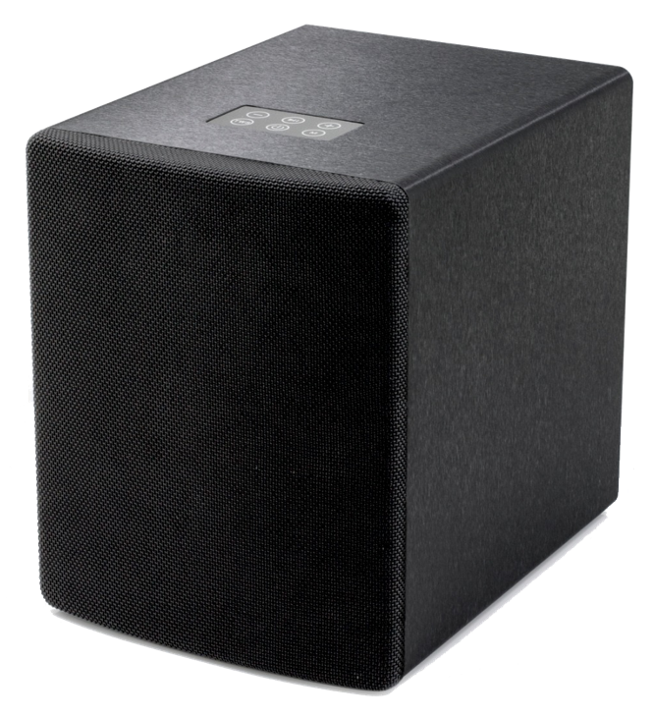
A hi-fi stereo wireless music system featuring two identical active speakers deploying the latest in True Wireless Bluetooth technology to connect to each other with no connecting cable between left and right speaker. Simply plug into the electrical power and switch each unit on. Power on the Left speaker first (this becomes the master) and the Right unit will become the Slave. Within a few seconds they will connect ready for a Bluetooth playback source to be paired to them as a single device or connect to one of the analog or digital connections on the rear of the speakers. In this instance, its only necessary to connect to the left speaker. Featuring our proprietary dual concentric driver with metal alloy diaphragm capable of delivering amazing lows, mids and highs accurately and with great control. The stereo soundscape is comparable to systems carrying a much higher price tag. Perfect as a substantial stereo system or as an alternative to a TV soundbar. A powerful listening experience and as simple as possible to set up. A hi-fi grade system with no extra electronics or cables to clutter your living space.
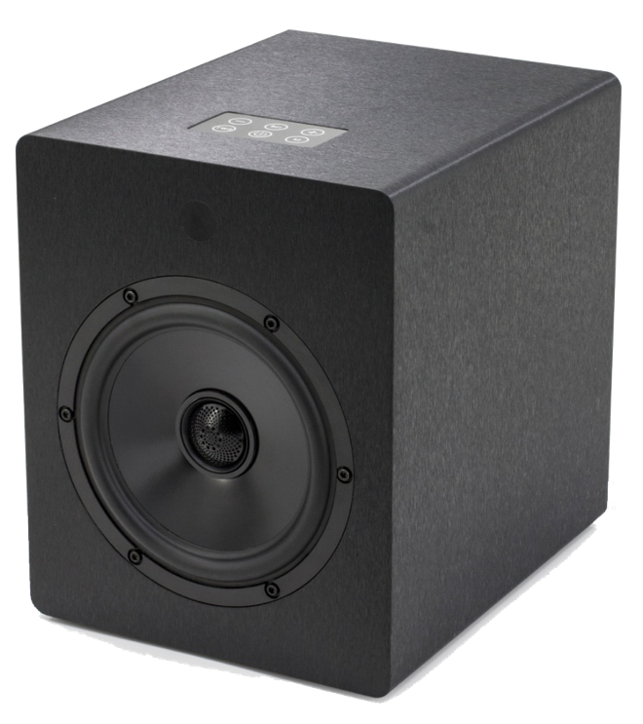
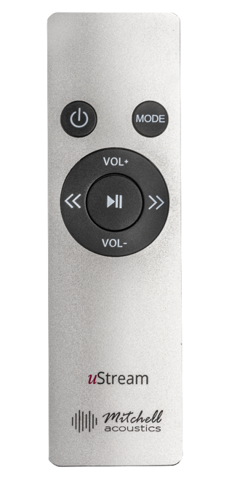

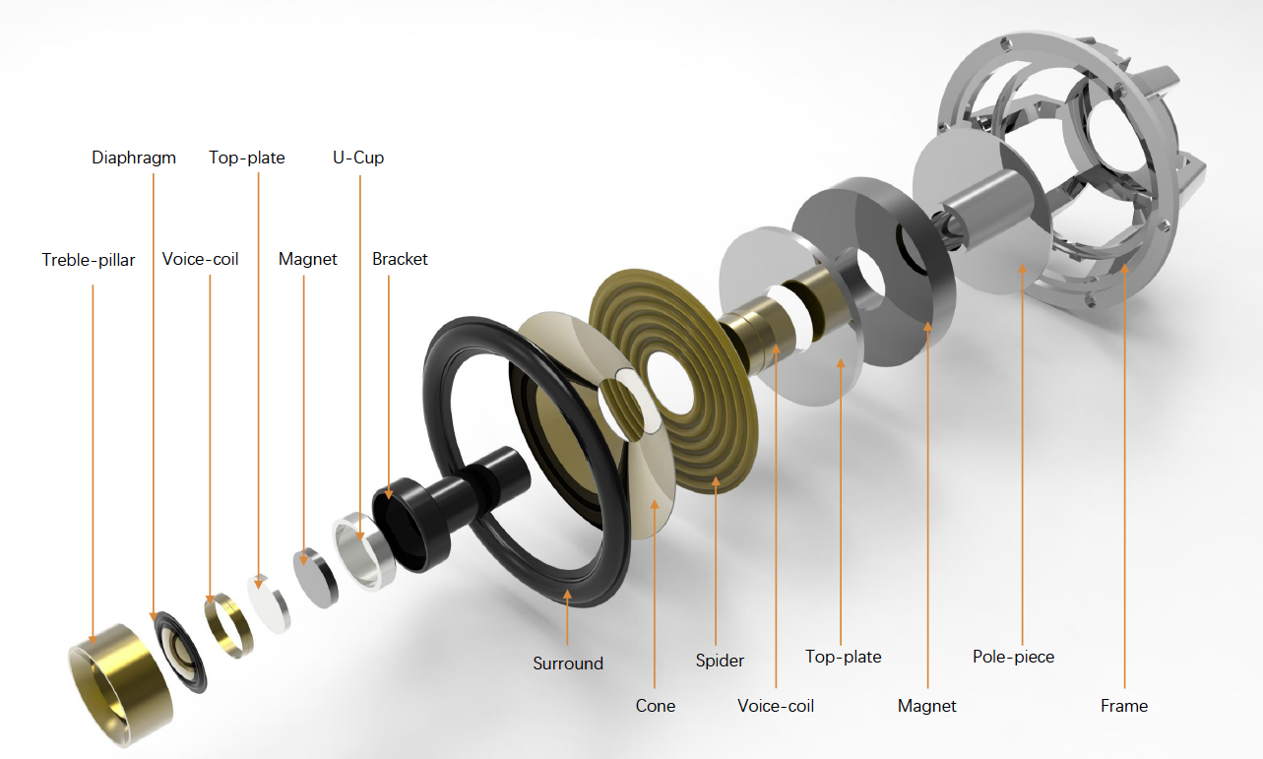

Features & Benefits

FEATURES | BENEFITS
A quality British audio brand you can trust | - Developed by Paul Mitchell, award winning audio equipment designer & musician/producer  - Find him on Spotify! Search Paul Mitchell & The Chaps Quartet  - “We made a basic decision when designing our products, that it would be easier to explain the price once, than apologise for poor quality forever. You’ll be glad we did”
Audiophile grade 50 watt Texas Instruments digital amplifier for mid and 30 watt for tweeter | - Bi-Wired with separate amp for each driver.  - Sound quality far exceeds the price tag.  - 80 watts RMS per channel  - A stereo soundscape that makes you feel like you are there!
Proprietary coaxial driver design sharing same back plate and magnet | - Damage proof tweeter and woofer  - Space saving design that doesn’t compromise on sound quality
Automatic TWS Bluetooth speaker pairing | - When powered on, speakers will pair automatically in seconds. No app to download, no wifi to connect  - NO CONNECTING CABLE BETWEEN LEFT AND RIGHT  - Unrestricted placement in your living space.
Soundbar Killer!  Connect to a TV | - Use either side of the TV instead of a soundbar and experience a stereo cinema effect in your home.  - No custom installation required  - No separate sub needed  - All TV sound is enhanced. Movies, Sports, Music
Custom designed voice coil with 20oz neodymium magnet | - Bass clarity the defies the compact cabinet size  - No need for separate sub-woofer
Combined mid/bass driver & metal tweeter | - Child finger proof. No way to ‘dent’ driver cone
Aluminium remote control handset | - Control power, volume, track next/prev from a real metal remote not a cheap plastic one!
Digital optical, RCA and mini-jack inputs | - Connect other sound gear like a TV, CD player, audio player, games console
USB socket will power external 5v music player | - Charge phone or connect external 5v to power such as the WiiM Mini audio player
2 year ‘no quibble’ warranty | - Peace of mind and proof of our belief in our products

Rated Output Power | 60W woofer x 2, 20W tweeter x 2W, 1 kHz,0.5 % THD (IEC) per unit
Dynamic Power | 160W RMS (80W RMS per channel)
THD (Total Harmonic Distortion) | THD < 0.5% at 1W 1KHz
Impedance | Bass driver 4 ohms, Treble driver 6 ohms
Frequency Response Range | 30Hz – 18KHz20 Hz-20KHz
Signal to Noise Ratio | > 80dB
Digital Inputs | OPTICAL 1 (Rear)
Analog Inputs | RCA x 2, 3.5mm mini-jack
Power Supply | DC 24V via AC 110-230V, 50/60 Hz power supply
Amplifier | Texas Instruments TPA-3116D2 Class D (bass) MVS JRK8280 (treble)
Speaker Driver Size | 165mm bass driver, 32mm treble driver
Diaphragm | Magnesium Alloy woofer / Silk composite tweeter
Bluetooth Chipset | MVSILICON BP1048B2 Version 5.0 SBC Codec with TWS (capable of 24/48 @ 345kbps) Profiles supported: A2DP/AVRCP/HFP/HSP/OPP/HID/SPP/PBAP GATT/SM
Origin | China
Accessories | DC power adaptor, US/Canada cable , EU cable, EU-UK adaptor  Remote control handset, RCA to 3.5mm cable, 3.5mm to 3.5mm cable
Dimensions | Unit Dims: (W x H x D) 205mm ( 8^{1/16}”) x 249mm (9^{13/16}”) x 249 mm (9^{13/16}”) (each spkr)  Packaging Dims: 40cm (15^{3/4}”) x 40cm (15^{3/4}”) x 50cm (19^{11/16}”) (2 spkrs per box)
Weight | 5kg (11lb) each speaker (Gross box weight 17.5kg (38lb 9oz) per set)
Barcode | EAN: 5060832950022 (black) 5060832950039 (white)  UPC: 860008515957 (black) 860008515964 (white)
SKU | 6020205
Loading | 48”×40” US pallet (1219x1016mm) 1200x1000mm GMA pallet = 18 units  Euro Pallet = 12 units. 20’ cntr 280 pcs, 40’ cntr 600
HS Tariff Code | 8518220090
SPECIFICATION

